**Table of Contents**

|  |  |
| --- | --- |
| **Contents** | **Page Number** |
| Introduction | 03 |
| Circuit Diagram | 04 |
| Working & Design of  Circuit Components | 05 |
| Component Description | 06 |
| Price Table | 07 |
| PCB Layout | 08 |
| Photo of Breadboard  Implementation | 09 |
| Photo of PCB  Implementation | 10 |
| Future Improvement | 11 |
| Conclusion | 12 |

**Introduction**

Rain water and wind direction detector circuit detects the appearance of rain as well as the direction of wind. The presence of water can be determined by an op-amp. When the positive input voltage of the op-amp is greater than the negative input voltage, then op-amp produces output and LED flames up. It indicates the presence of water. The circuit also detects the direction of the wind by flaming up different colour LEDs. For the wind direction circuit, NPN transistors are used as switches. When a transistor is on, it makes a LED flames up. Thus direction is determined.

**Circuit Diagram**

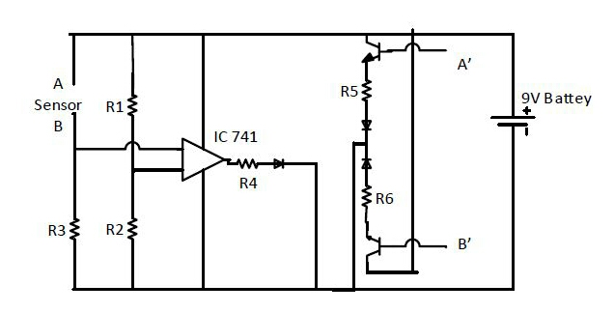

**Figure 01:** Circuit Diagram of Rain Water & Wind Direction Detector Circuit.

**Working and Design of Circuit Components**

For Rain Alarm Circuit, op-amp IC-741 is designed as voltage comparator. When there is no

water in the sensor the inverting input (Pin-2) is higher than the non-inverting input (Pin-3)

and so output becomes low as a result there will be no output. When sensor gets water,

Pin-3 gets higher voltage than Pin-2 and output will be higher and consequently the LED

flames up.

For Wind Direction Detector Circuit, transistors are used as switch. When conductor touches point A then the corresponding transistor gets a base tPoi point A then corresponding transistor gets a base current and the current flows through

the first LED because of it’s in forward bias and at the same time the other LED remains

off because of it’s in reverse bias. So the first LED blazes and we get wind direction.

When conductor touches point B then the corresponding transistor turns on as it has got a

Base current and the second LED gleams because of forward bias happening while the

other LED is in reverse bias.

**Component Description**

**Op-amp (IC-741):**Here, op-amp is used as a voltage comparator. It compares the inverting

and non-inverting input voltage and shows output when non-inverting input voltage is

greater than that of the inverting input.

**Transistor (BC-547):** Transistor BC-547 is a NPN transistor, which is used as a switch

here. NPN transistor acts as a open switch when there is no voltage applied on its base (B)

and It acts as closed switch when there is some voltage at its base. Generally 0.7 volt

is enough to get it fully conducted.

**Resistors:** We have used three 10 kilo ohm and three 150 ohm resistors in this project.

**LED (Light Emitting Diode):** Three different colour LEDs are used in this project.

**Conductor:** We used Aluminum foil as the conductor.

**Battery:** A 9V DC battery source is used to power the circuit.

**Price Table**

|  |  |
| --- | --- |
| Components Name | Price (Taka) |
| Op-amp (IC-741) | 15 |
| Resistors (6 Pieces) | 6×1=6 |
| Transistors (2 Pieces) | 2×2=4 |
| LEDs (3 Pieces) | 1×3=3 |
| 9V DC Battery (1 Piece) | 25 |
| Aluminum Foil | 10 |
| Connecting Wires | 20 |
| PCB (Printed Circuit Board) | 30 |
| Report Printing & Binding Cost | 80 |
| Battery Cap | 15 |
| Total | 208 |

**PCB Layout**

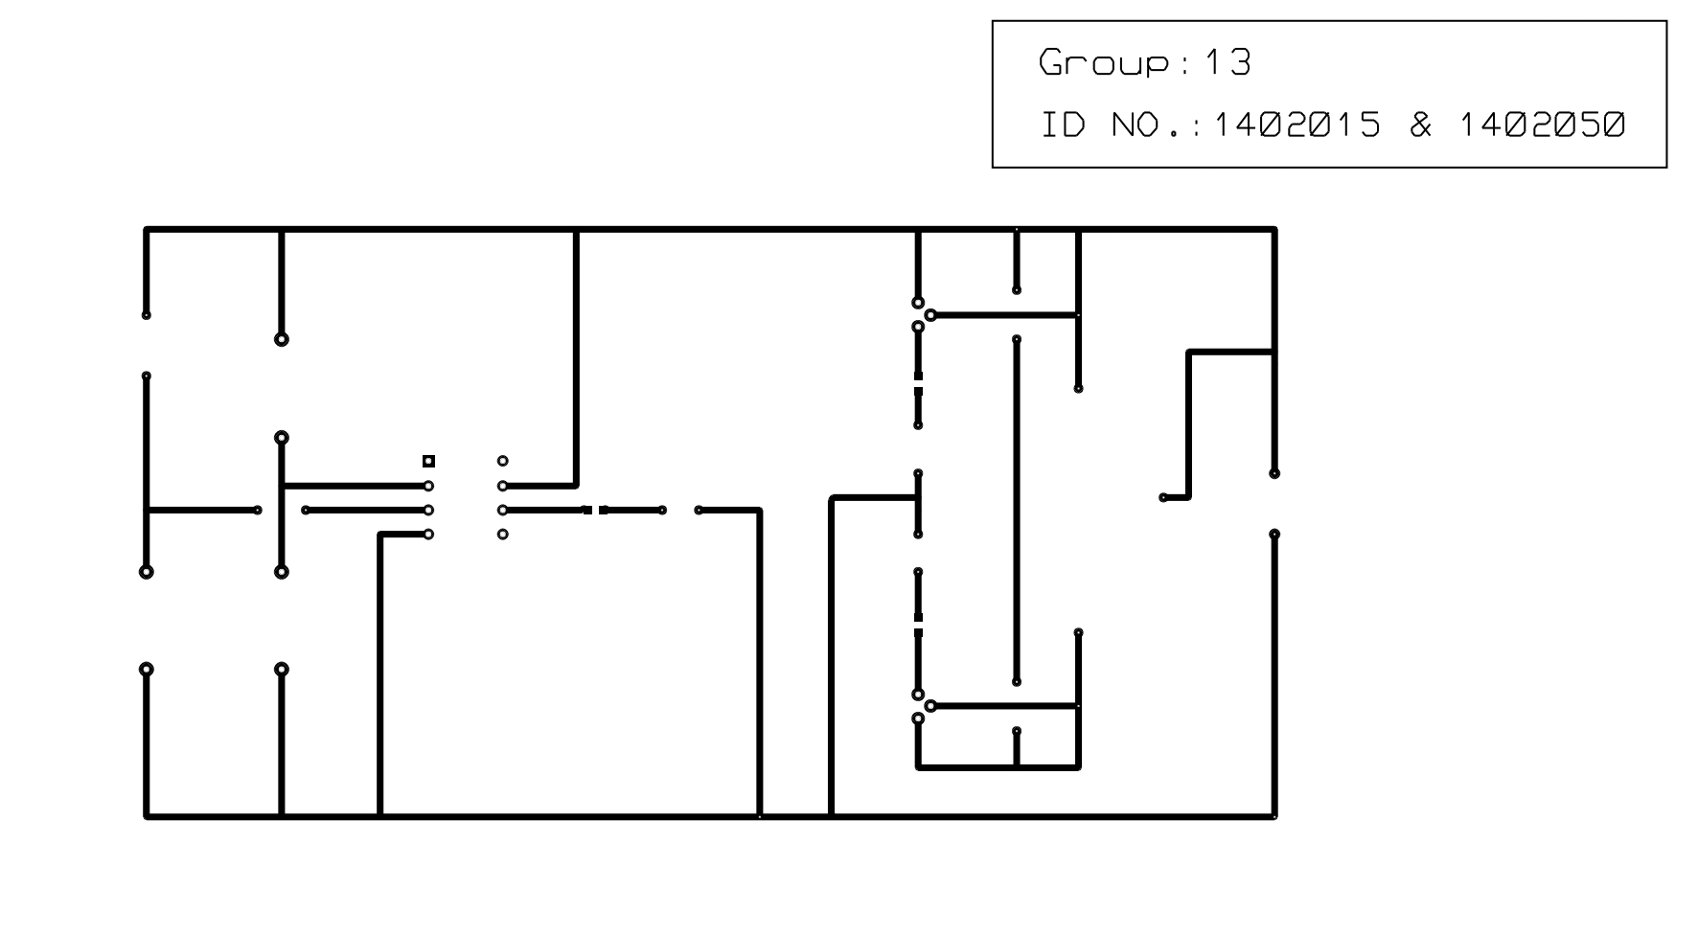

|  |
| --- |
|  |
|  |
|  |
|  |
|  |

**Figure 02:** Photo of PCB Layout of Rain Water &

Wind Direction Detector Circuit.

**Photo of Breadboard Implementation**

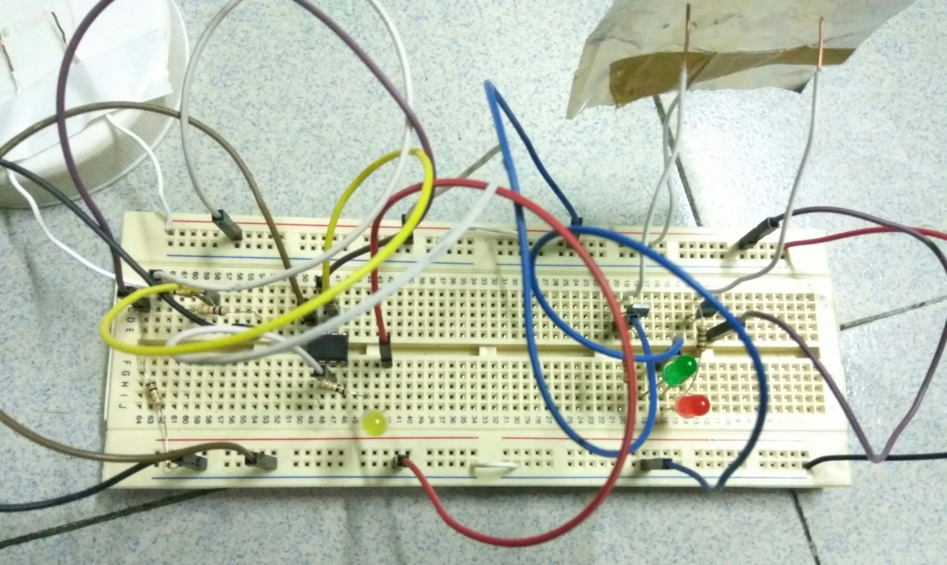

**Figure 03:** Photo of Breadboard Implementation of Rain

Water & Wind Direction Detector Circuit.

**Photo of PCB Implementation**

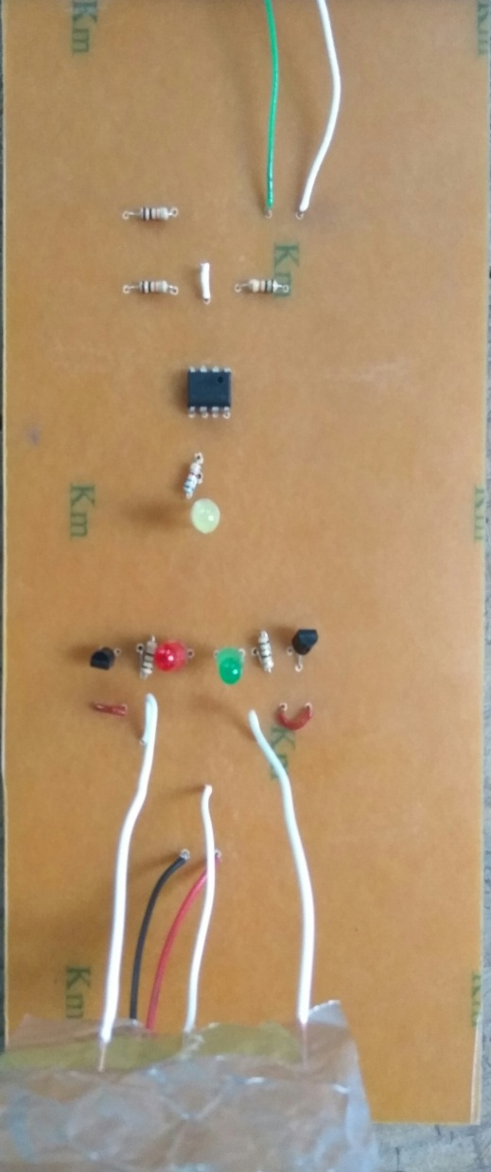

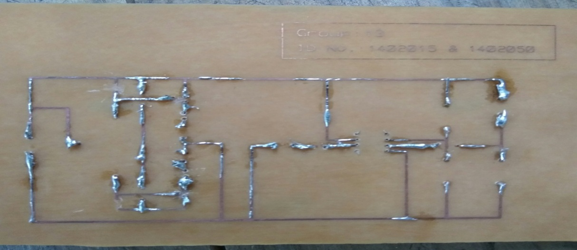

**Figure 04:** Photo of PCB Implementation of Rain Water &

Wind Direction Detector Circuit.

**Future Improvement**

Rain alarm can be improved in future in such way that it can also measure how much hhhhhomucmillimeterscale. For this we can use rain is falling in millimeter scale. For this we can use transistors as switch.

For wind direction detector, we have used it for detecting two opposite direction but it can

be improved more to multidirectional detector circuit by using micro-controller. By this wcacan measure in which direction (East, West, South, N we can measure in which direction (East, West, North, South) wind is flowing and it can

be much helpful to us.

**,**

**Conclusion**

By this rain water and wind direction detector circuit, we have learned about the working

principle of the IC op-amp. We have known that when an op-amp gets a higher voltage in

positive voltage than that of negative one then op-amp produces output, but when its

negative input voltage is greater than the positive voltage then it will not produce output.

We have also learned about the use of transistor as a switch. When it gets a base voltage

then it acts as short circuit or as a switch otherwise it acts as an open path. We have also seen

the operation of water as a conductor.